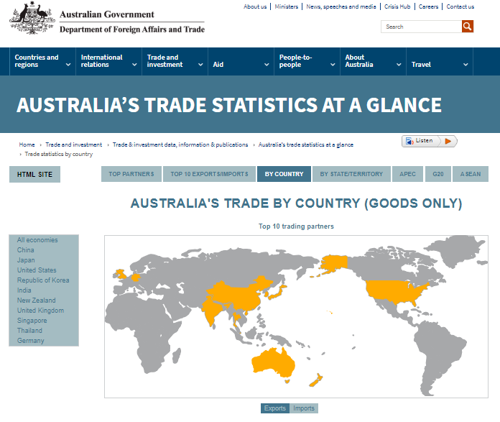
Exploring Australia’s Economic Trade Markets

Investigate this tab mainly

Click here for imports or exports

https://dfat.gov.au/trade/resources/trade-at-a-glance/Pages/default.aspx
Record interesting facts about Australia’s imports and exports by using the interactive website above:
- To find the webpage displayed above, go to our class Weebly and click on the tab:
‘SUBJECTS’ Humanities Asia Our Neighbours ‘Australia’s Trade Statistics’ image
- Click on the tab ‘BY COUNTRY” to explore Australia’s trade with different countries. Explore this website to discover what Australia imports and exports.

- Using a Google Doc, create a table like the one below and record the top 10 countries that Australia exports (sells) their products to. Also include between 7-10 columns to record the top products Australia exports to these countries:
Top 10 Countries Australia Exports Products to
Name of country | 1st | 2nd | 3rd | 4th | 5th | 6th | 7th | 8th
- Create a second table like the one below and record the top 10 countries that Australia imports (buys) their products from. Also include between 7-10 columns to record the top products Australia imports from these countries:

Top 10 Countries Australia Imports Products from
Name of country | 1st | 2nd | 3rd | 4th | 5th | 6th | 7th | 8th

- Compare your statistics and write a summary about some interesting things you have learnt relating to Australia’s trade with other countries, particularly Asia.

* * * Print and glue your answers to this investigation into your HASS.
Make sure your Google doc has a clear title and your name on it.

